Normal Distribution also known as Gaussian distribution is nothing but symmetrically distributed curve from Mean where Mean=Median=Mode=Zero and 1 unit standard deviated.

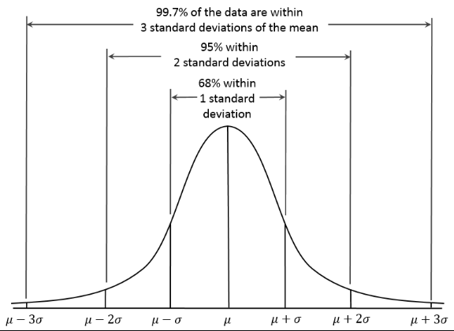

Probability Distribution is nothing but probabilities of occurrence of different possible outcomes. A probability distribution is specified in terms of an underlying Sample space. Probability Distribution can be of

1. Continuous or (Temperature on given day)
2. Discrete (Coin flip)

Normal Distribution is commonly encountered continuous probability distribution.

Since Probability is a Sample space and N number of Sample space contribute to Normal distribution which is continuous